https://leetcode.com/problems/calculate-delayed-arrival-time/submissions/2191285722/

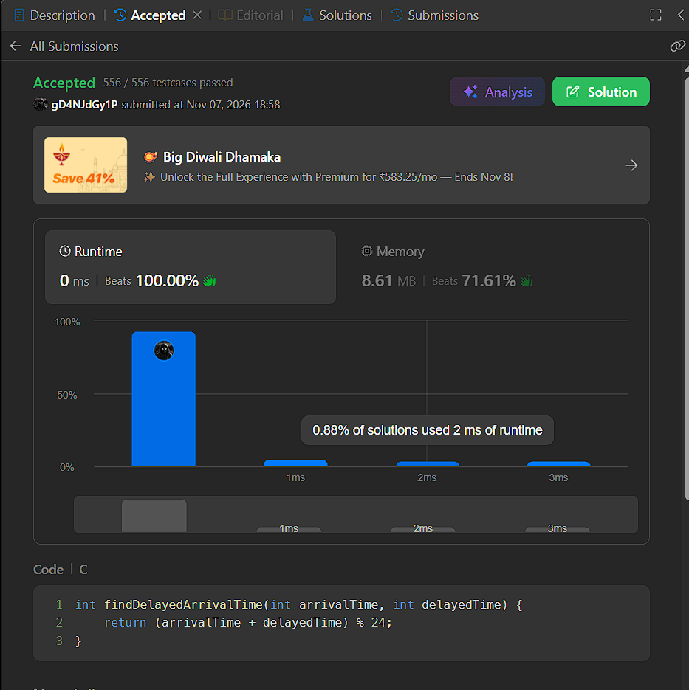

int findDelayedArrivalTime(int arrivalTime, int delayedTime) {
return (arrivalTime + delayedTime) % 24;
}

